File
Double-click to open:

Example of how the file looks:
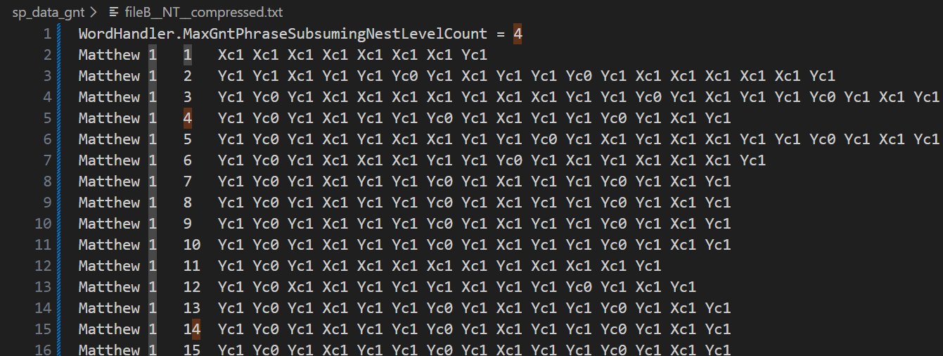

Legend
c0 -- no phrase for the word
c1 -- 1 phrase for the word
…
c4 -- 4 phrases for the word (this is max in NT)

You can simply search for "c…" phrase in the attached file to find all instances. "c" stands for "count," meaning MaxGntPhraseSubsumingNestLevelCount. Subsuming means that the phrase includes another phrase without breaking. In other words, a subsuming phrase includes all the words within its range, although other, shorter, phrases, also includes some of its words.

Brief analysis

Verses with 4 subsuming (non-breaking!) levels
Only 1 verse in NT:
Romans 5 14 Yc0 Yc1 Xc1 Yc1 Xc1 Xc1 Xc1 Yc1 Xc1 Xc1 Yc1 Yc2 Yc2 Xc2 Xc2 Xc2 Xc2 Xc2 Yc2 Yc3 Yc3 Xc3 Yc3 Yc4
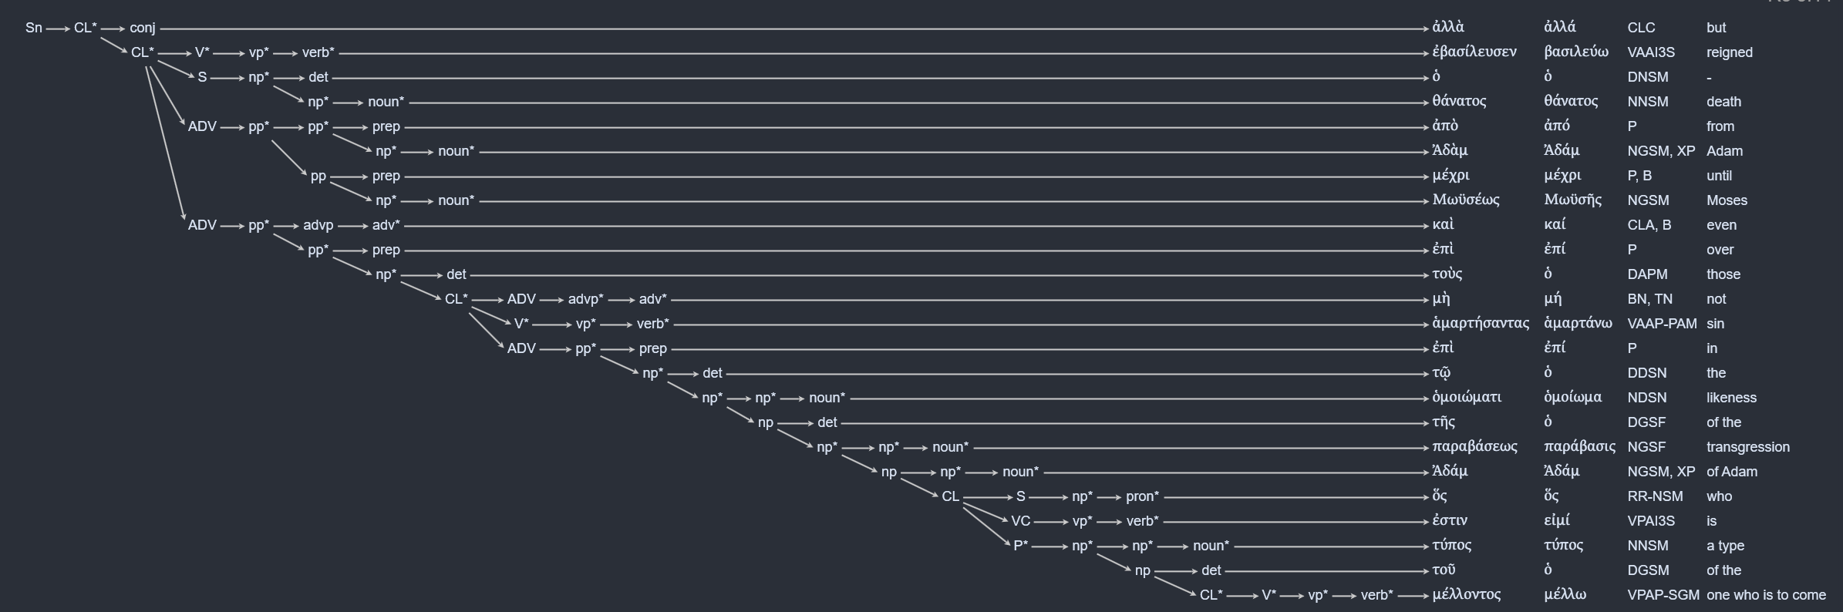

Verses with 3 subsuming levels
There are 253 words in NT that participate in exactly 3 levels of subsuming.
The earliest NT example is in Romans:

Romans 7 4 Xc0 Xc0 Yc0 Xc1 Yc1 Yc1 Xc1 Yc1 Xc1 Xc1 Xc1 Xc1 Yc1 Xc1 Yc1 Yc2 Yc2 Xc2 Yc2 Xc3 Yc3 Yc3 Yc0 Yc1 Xc1 Yc1

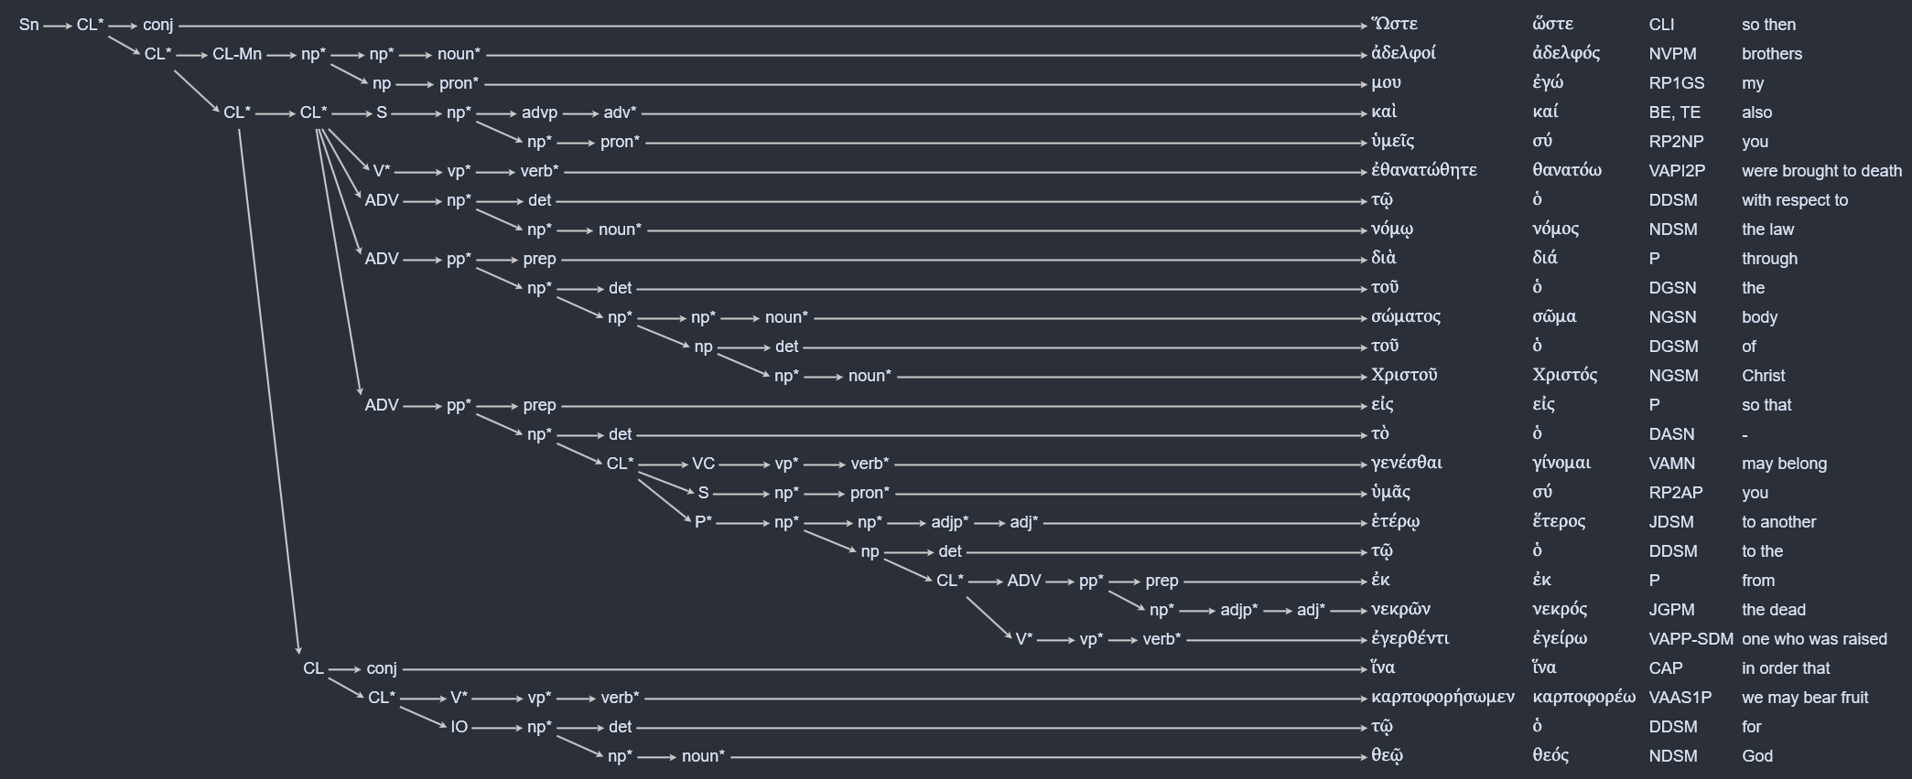

Verses with 2 subsuming levels
There are 8605 words in NT that participate in exactly 2 levels of subsuming.

Preliminary conclusion
The current information is raw and is still under discussion.
The GNT subsuming phrases are not exceptional; they are based on 8859 NT words that is approximately 6.4% of the words total in NT. Thus, they provide ample of training data.
Additionally, the overall impression that is based only on the two verses mentioned above (Rom 5:14; 7:4), is that the subsuming phrases may be making full syntactical sense.
Therefore, the subsuming phrase structure should be retained, that is, encoded in AI-training and incorporated into the future LXX syntactical structure.

